CHECK APPROPRIATE BOX
BINDING
NON-BINDING
The following Resolution is hereby submitted to the Resolutions Committee of the 2025 IL RLCA State Convention in Springfield, Illinois for consideration and appropriate action.

ISSUES
Check one:
AUTOMATION MAILCOUNT VEHICLE
BENEFITS RELIEF DAY WORK RULES
EMA RETIREMENT
GRIEVANCE PROCEDURES SALARY OTHER
LEAVE REPLACEMENTS CONSTITUTION
The following procedures are suggested for effectively presenting state – adopted Resolutions:

- Place only one Resolution per sheet.
- Formatting instructions: Font-Times New Roman; Font Size 11;
New Language BOLD; Omitted Language Strikethrough
- Indicate if the Resolution is intended to be binding or non-binding (above).
- Indicate the issue this resolution concerns (above).
- Identify any Handbooks, Manuals, or Written Documents to be amended:
By: (a) Name of Document
(b) Article |  | Section |  | Paragraph

- Explanatory paragraphs should be headed as follows: (If spaces below are inadequate, use additional sheets with the appropriate heading).

WHEREAS:

BE IT RESOLVED:

INTENT OF / REASON FOR CHANGE:

Submitted By: __________________________________________
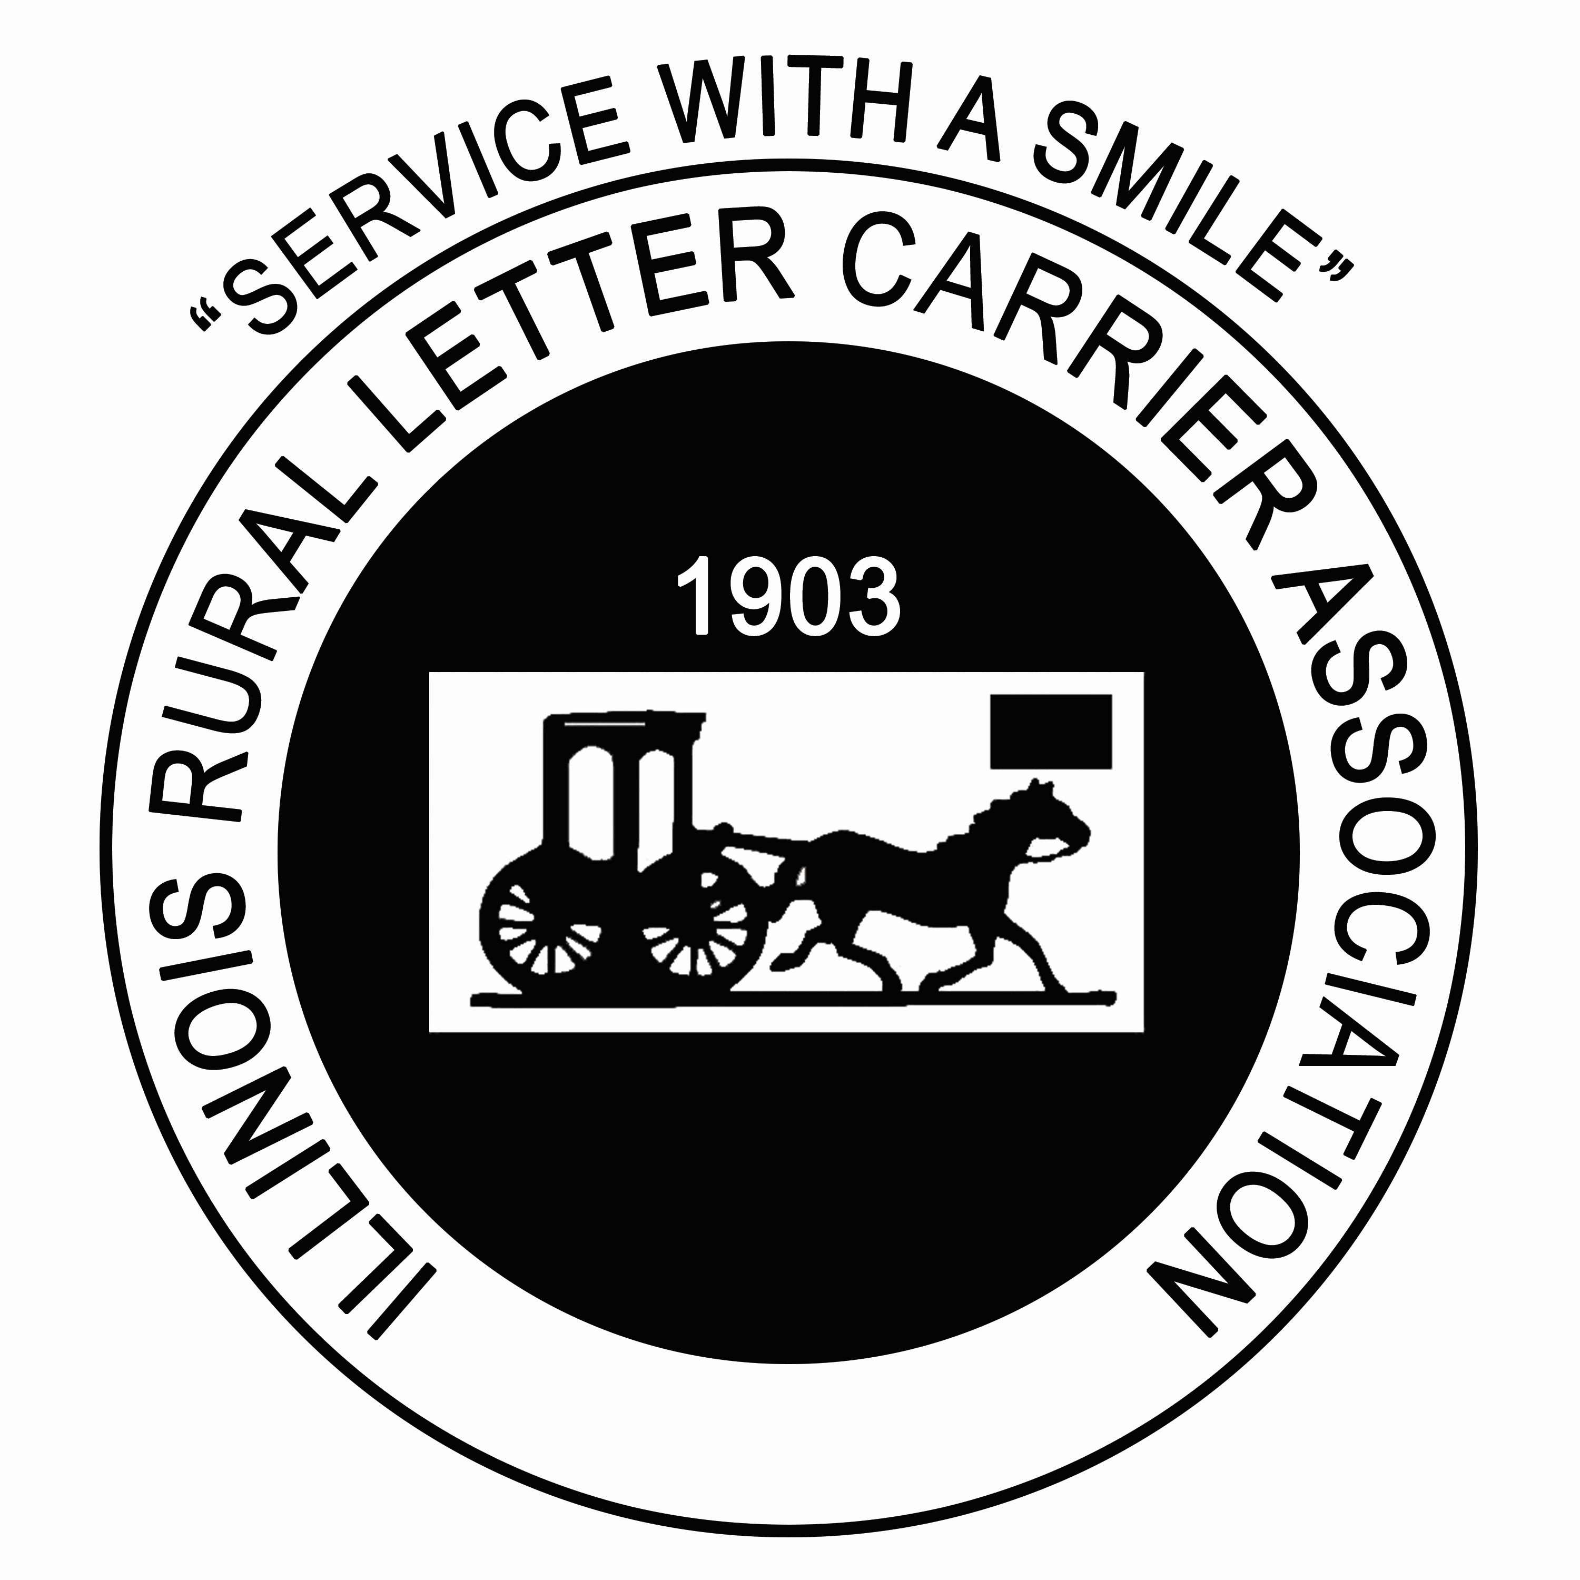

(Please print)
Signature ______________________________________________
If Individual, individual signs/ If by County,
County Secretary signs
Date
Return by June 15th, 2025 to:
Resolutions Committee Chairman Megan Beck 920 E 2750 North Rd Mansfield, IL 61854 Email address: mbholoch@yahoo.com Phone (217) 417-9495
Phone: 815 742-7091

